# CS 255 System Design Document Template

**Larry Jones** **• CS-255-T4173**

## UML Diagrams

### UML Use Case Diagram

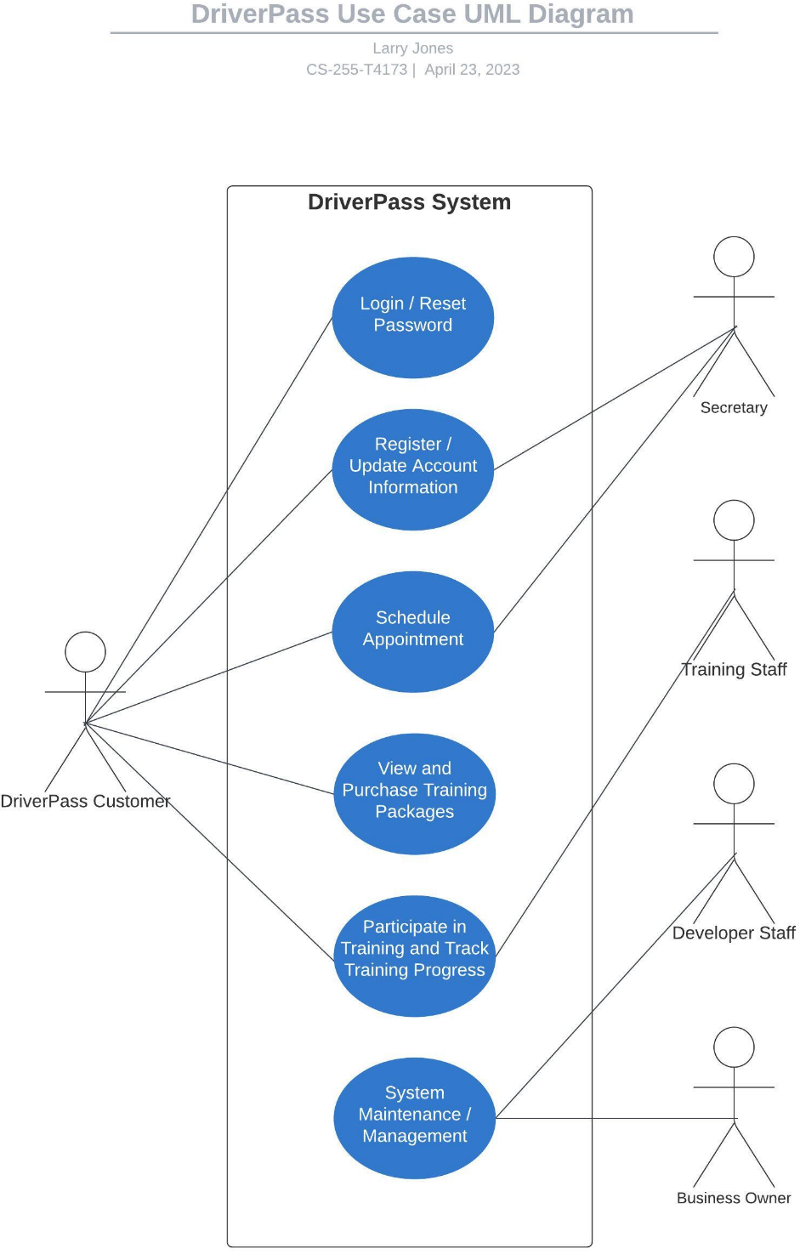

### UML Activity Diagrams

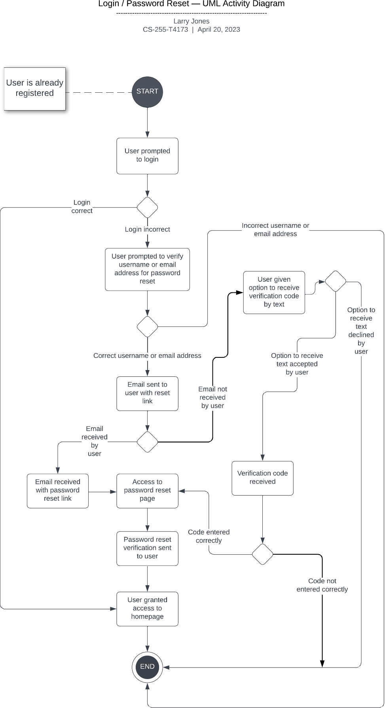

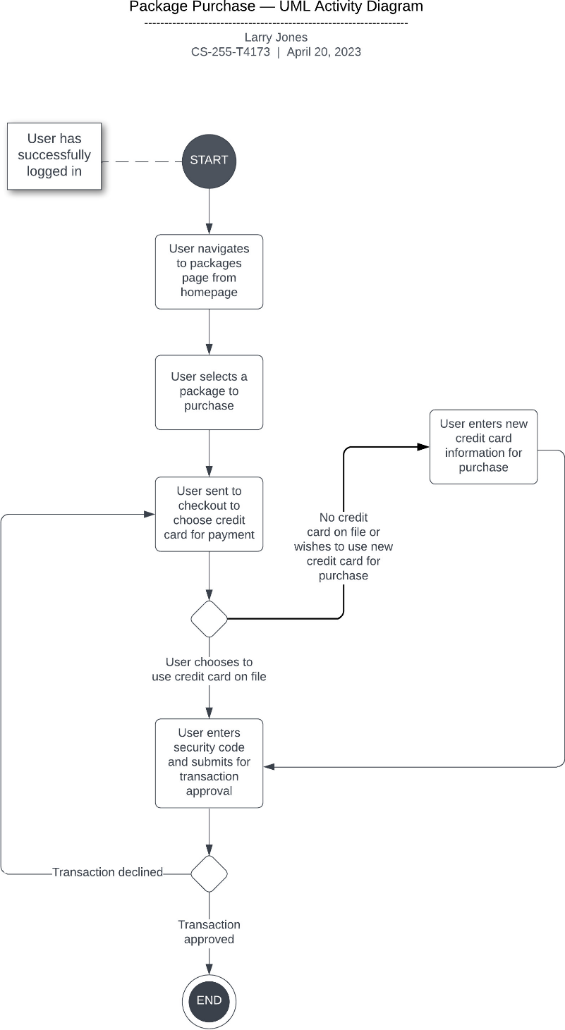

### UML Sequence Diagram

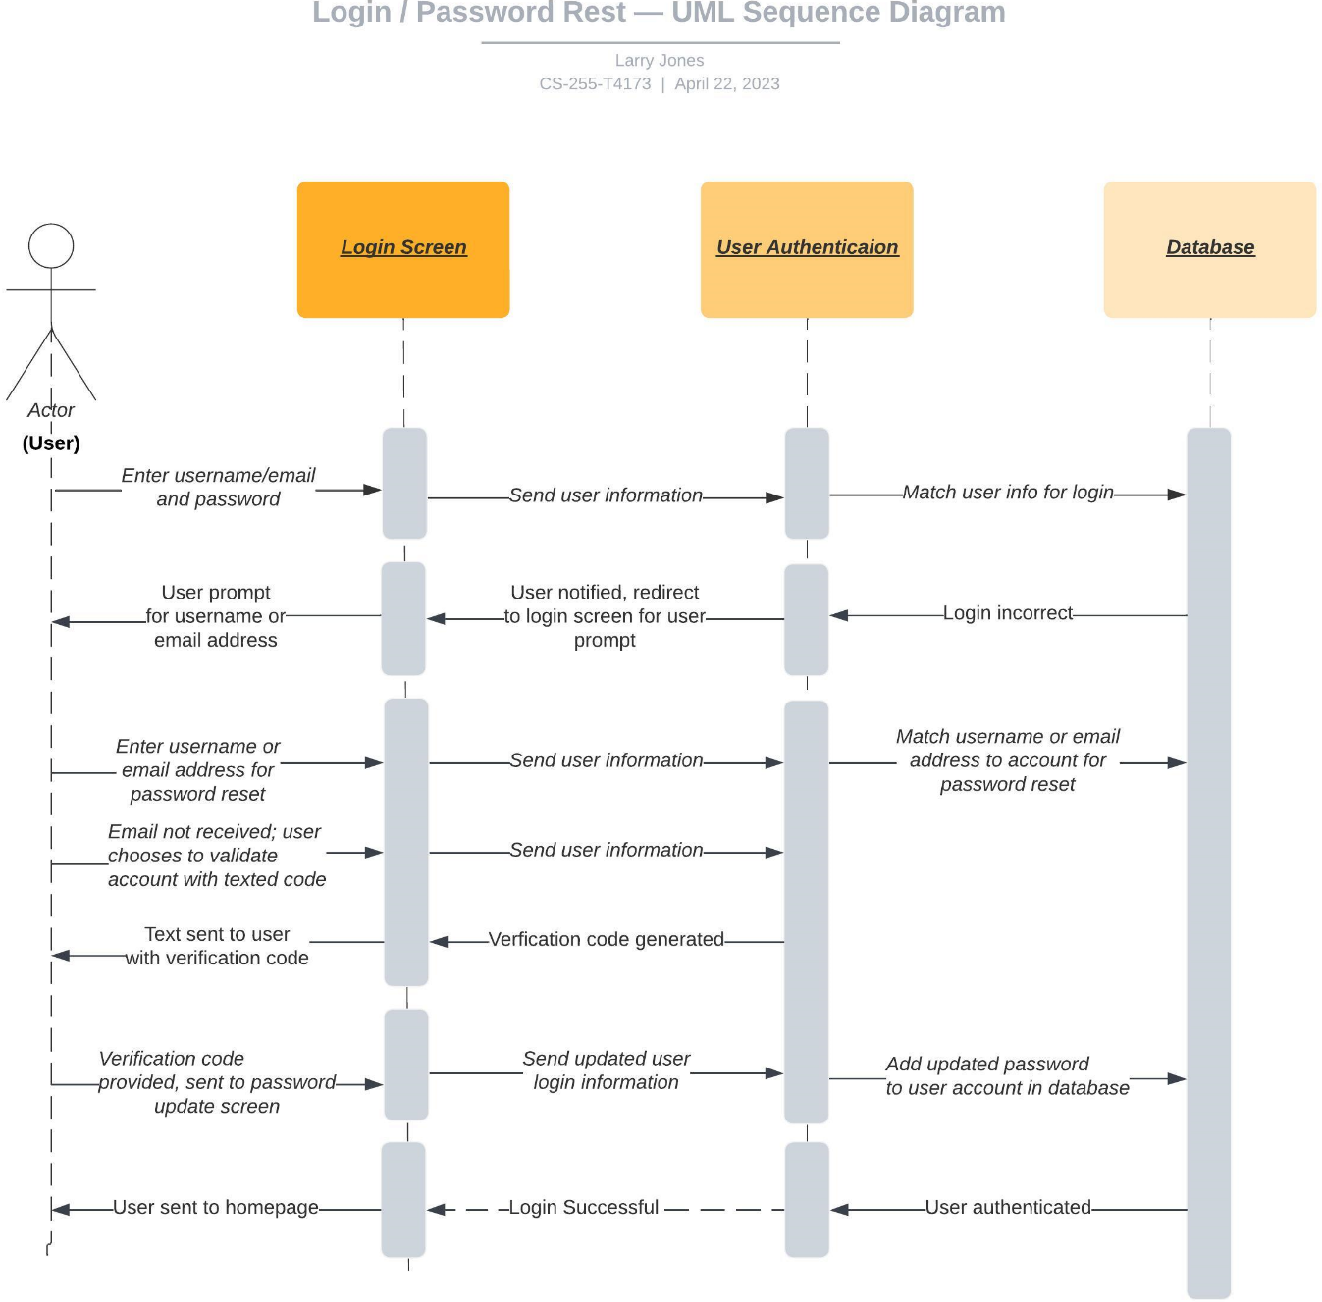

### UML Class Diagram

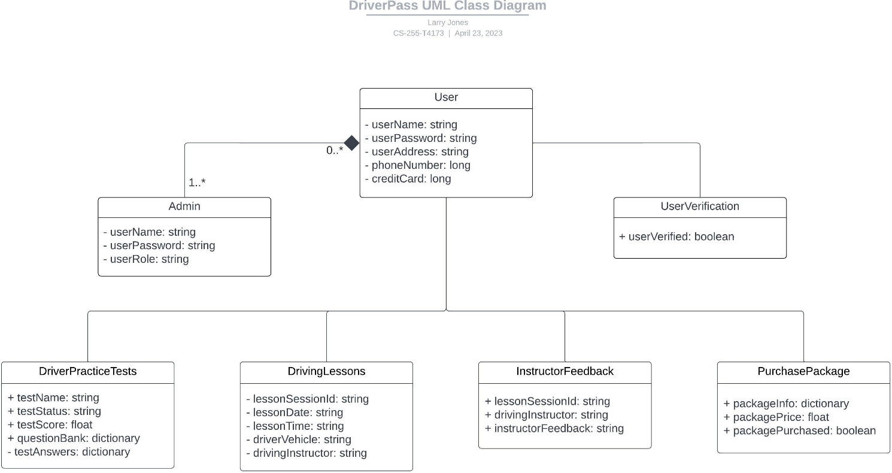

## Technical Requirements

**Software:**

DriverPass system application (universal responsive system for PC and applicable devices)

Administrator server access system

Developer software for DriverPass system application (cloud-based)

Web-based application concurrent with PC and future mobile apps

Anti-virus and firewall security suite for site

**Hardware:**

Desktop PC (quantity as needed) with sufficient memory, ethernet connectivity and necessary attachments for stationary and wireless access

Laptop access (quantity as needed) with sufficient memory and appropriate cloud connectivity

Mobile device access (quantity as needed) with sufficient memory and appropriate cloud connectivity

Home-based server with programming and network administrator access with consistent internet connection

**Infrastructure:**

Home-based server / mainframe location

Office space for owner, administrator, training staff, developer staff, secretary, conference room

Classroom space for training, lecture, or video viewing

Home-based power source

Home-based consistent internet connection source

Consistent phone-line access (land based) for credit card processing and business calls

Training space for on-site maneuver training

Parking space for staff and customers

Trademark and licensing for DriverPass company, brand, and system application